 | 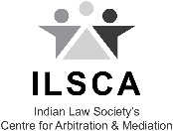
ILS Centre for Arbitration & Mediation, Pune
in association with
ADR ODR International, UK
announces
Online Civil/Commercial Mediation Training Programme
Course Highlights
- To help participants understand the basics of mediation process and establish a standard body of skills and knowledge to qualify as efficient mediators.
- Online only training.
- Internationally recognised and highly acclaimed training programme.
- Certification and empanelment upon successful completion.

DATE
25th November 2022 to 3rd December 2022

TIME
4 p.m. to 8 p.m. everyday
9 a.m. to 5 p.m. on Assessment Day
(3rd December)
FEE
INR 30,000 + GST (Students)
INR 40,000 + GST (Professionals)

Recognised By:
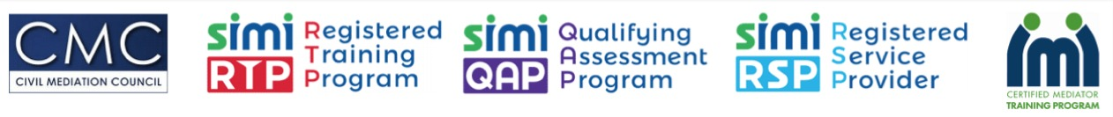

Register at:
https://www.adrodrinternational.com/india-civil-commercial-mediation-training

Contact:
ilsca@ilslaw.in

